Carrickleck NS SCHOOL CALENDAR FOR 2023/2024
Return from  Summer Holidays | Wednesday August 30th 2023 | School re-opens | 
Halloween Mid-Term | Monday 30th October 2023 to  Friday 3rd November 2023 inclusive | School Closed | 
Christmas Holiday | Friday 22nd December 2023  Monday 8th January 2024 | School Closing  School re-opens | 
New Spring Bank Holiday | Monday 5th February 2024 | School Closed | 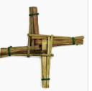
Spring Mid-Term | Thursday 15th -February to  Friday 16th inclusive | School Closed | 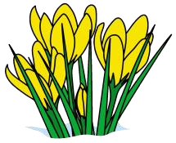
St Patrick’s weekend | Monday 18th March 2024 | School Closed | 
Easter Holidays | Friday 22nd March 2024  Monday 8th April 2024 | School Closing  School re-opens | 
May Holiday | Monday 6th May 2024 | School Closed | 
June Holiday | Monday 3rd June 2024 | School Closed | 
Summer Holidays | Friday 21st June 2024 | School Closing | 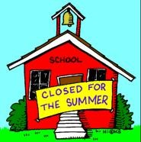
This calendar is subject to change.

